Field Scout TDR 300 Soil Moisture Meter

Specifications
- Measurement Principle: Proven time-domain measurement methods
- Measurement Units: Per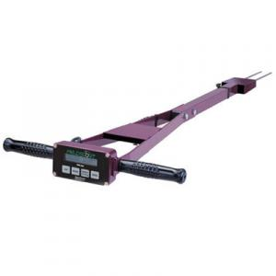cent volumetric water content
- Resolution: 0.1% volumetric water content
- Accuracy: ±3.0% volumetric water content with electrical conductivity < 2 mS/cm
- Range: 0% to saturation (Saturation typically around 50% volumetric water)
- Battery/Life: 4 AAA alkaline batteries; approximately 12-month battery life
- Data Logger: 3,250 measurements without GPS; 1,350 with GPS/DGPS
- Software and PC cable included
The TDR 300 Soil Moisture Probe Rods
Measurement rods are purchased separately for Field Scout TDR products. They come in lengths of 3.8, 7.5, 12 or 20-cm to suit the desired depth measurement. These stainless-steel rods can be changed out while testing in the field.
Based on proven time-domain measurement technology, these portable units accurately measure soil moisture across the full range of soil moisture conditions. Install PVC access tubes and take readings deeper in the soil profile for permanent crops like apple, grapes, and nut crops.
The TDR 300 has two volumetric water content modes; one for standard soils and one for higher clay soils. In volumetric water content (VWC) mode, the meter converts a measured electrical signal into percent soil moisture content using an equation valid over a wide range of mineral soils. In irrigation mode, the meter displays a relative water content (RWC) on a scale of 0 to 100 corresponding to a user-defined upper and lower soil moisture reference level. Water deficit, the amount of water needed to bring the soil moisture content up to the upper reference level, is also calculated and displayed. The reference levels are easily programmed into the meter with the accompanying software. Create up to 2 management sites based on your soil types and crop needs. Use the raw reading mode (measurement period in microseconds) to do soil-specific calibrations.
- Instantaneous readings of root zone soil moisture
- Connects to any GPS receiver with serial output**
- Equipped with internal data logger and RS-232 port
- TDR 300 meter includes soft-sided carrying case
- Rods sold separately

http://www.nzsti.org.nz/soil-water/tdr300moisturesensor/

